**UX03. Open Adventure Town View**

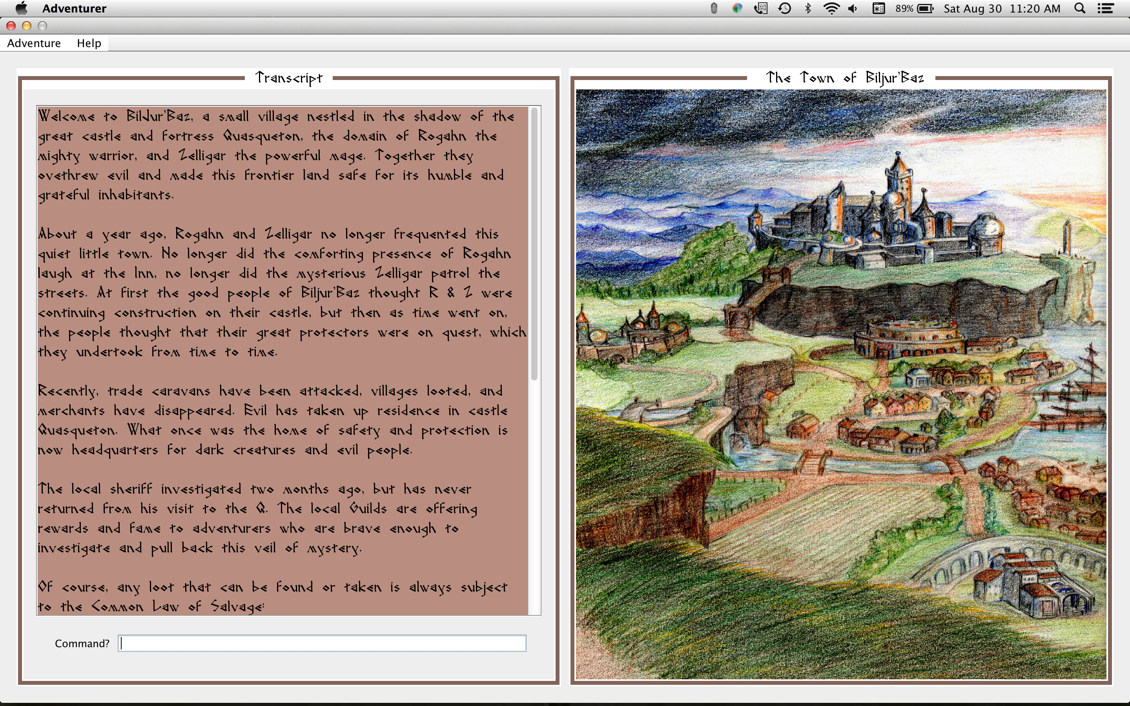

This mainframe view is displayed when an Adventure is opened. The *ImagePanel* is shown on right, and the *IOPanel* on left. The IOPanel contains the *Transcript* text area for output, and the command line for input.

In general, the scrolling Transcripts text area shows a description of the image in the Image panel.

**Image Panel contains:**

* Town view (initially) with Building hot zones (rectangles that highlight a building image in the town). Hovering over a hot zone displays the name and type of building as a tool tip.
* Clicking on a hot zone displays the building’s exterior view, and gives its exterior description. The image title displays the Building’s name and type.
* Clicking on the exterior Building view ENTERs the Building. See the ENTER use case.
* Entering TO TOWN, RETURN, or LEAVE in the Command line takes the Hero from the building exterior to the town view again. See the RETURN use case.

**Transcript panel** contains a description of the town when the adventure first opens, and when the town image title is double-clicked, or a Building selected. All output is displayed in the Transcript area. Transcript text scrolls as text is appended at the bottom, but when the town overview is first displayed, the scroll bar is at top of the description.

**Command line**: allows a building’s interior to be entered dwithout clicking, by ENTER [Building Name]. See the ENTER use case. The command is echoed to the output panel, and any resulting or errror messages are displayed there too.